28 February 2025

REFERRAL RESPONSE - HERITAGE

FILE NO: | Development Applications: 376/2024/1
ADDRESS: | 29-53 Victoria Road BELLEVUE HILL 2023
PROPOSAL: | Demolition of the existing outdoor swimming pool of Scots College and construction of a new swimming pool and associated facilities including pool plant room, spectator seating and storage area.
FROM: | Eleanor Banaag
TO: | Mr M D'Alessio

- DOCUMENTATION

The following documentation provided by the applicant has been examined for this referral response:
- Architectural Drawings by TKD Architects, dated 4 November 2024 and numbered
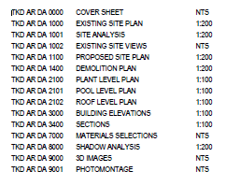
- Heritage Impact Statement by John Oultram, dated August 2024
- Statement of Environmental Effects by Urbis, dated 16 August 2024
- Aboriginal Heritage Impact Assessment by Urbis, dated x

- DESCRIPTION OF PROPOSED WORKS

The applications seeks consent to carry out Demolition of the existing outdoor swimming pool of Scots College and construction of a new swimming pool and associated facilities including pool plant room, spectator seating and storage area. at the subject site. Specifically, the works include:

- Demolition of the existing outdoor pool and pool plant room.
- Construction of a new outdoor pool with the following dimensions: 25m x 30m x 2.2m deep.
  - The dimensions of the new pool are an enlarged footprint of the existing pool. Although generally in the same location, the new pool footprint will encompass an existing open shade structure.
  - The pool depth with roughly be maintained. Due to the current graded depth of the pool, there are some areas of proposed minor excavation in order to increase the pool depth, and some areas of infilling the pool, all in order to create a consistent 2.2m depth.
- Construction of a new pool plant room along the northern boundary of the site in the same location of the existing pool plant room.
- Construction of new spectator seating and storage to the northern boundary of the site.
  - The structure is open to one side, with a skillion roof form. Tiered seating will occupy the area above the existing plant room, where there is currently an open shade structure.
- Installation of a new OSD tank to the east of the pool under the concourse and a small patch of turf.

- SITE INSPECTION / RESEARCH

The following research was undertaken in the preparation of this assessment:
- The site was (previously, if second response) inspected on the 28 February 28, 2025, externally from the public domain only.

Review of the following documents and photographic evidence:
• Council’s property system, to establish dates of earlier building and development applications for the subject and surrounding properties.
• Council’s photography files relevant to the immediate area
• Council’s heritage inventory sheets
• Council’s aerial photography and mapping database
• Google Maps – street view

- STATUTORY AND POLICY CONTEXT

The following statutory and policy documents are relevant to the application:
- National Parks & Wildlife Act 1974
- Woollahra LEP 2014
- Woollahra DCP 2015

- SIGNIFICANCE OF SUBJECT PROPERTY

Statement of significance
The subject site is a local heritage item, listed on the Woollahra Local Environmental Plan 2014, as item I67, “The Scots College”. It is also adjacent to the Aston Gardens Heritage Conservation Area.

The following Statement of Significance for each of the above items is taken from the State Heritage Inventory.

The Scots College (I67)
The Scots College is of cultural significance as an example of a private, boys’ secondary school that was opened on the site by the Scots College in 1895 in the house St. Killians that they had leased in the same year to allow for the relocation from Brighton-le- Sands.

The site was comprehensively developed from 1914 onwards when a series of purpose-designed buildings were constructed including the Middle School (1915). MacIntyre House (1919), Kirkland House (1926) and the Memorial Chapel/Anderson Hall (1956)
The place is strongly associated with Presbyterian Church that purchased the leasehold of the site in 1907 and that was instrumental in the establishment of the original school in 1893.

The College retains a number of significant, high quality, architect-designed buildings including Aspinall House (formerly St. Killians) (Mansfield Brothers), Middle School and MacIntyre House (Power and Adams), Kirkland House (Morrow Deputron and Gordon) and the Memorial Chapel/Anderson Hall (Frederick Glynn Gilling).

The place has operated as a school since 1895 and would have social significance for the Presbyterian Church that was instrumental in the establishment of the College, the thousands of pupils that have passed through its halls and their families and the numerous staff who have worked there. The school provides a social focus for the local community and continues to provide high quality, secondary education for boys.

(Source: John Oultram Heritage & Design, 2019)

Aston Gardens Heritage Conservation Area (C1)

The Aston Gardens HCA is an outstanding group of significant Inter-War flat buildings designed by prominent architects that remain largely intact in their fabric, 1927 subdivision pattern and garden settings. Aston Gardens is rare in that nearly every architectural style of the Inter-War period is represented in the one street. Many of the flats are large and many originally included servant’s quarters. The area is significant in demonstrating the move away from large freestanding houses to modern and fashionable flats during the Inter-War period and the changing planning regulations increasing the density of the inner suburbs of Sydney.

The Inter-War flat buildings are 2 to 4 storeys in height, in Spanish Mission, Georgian Revival and Art Deco styles in a landscaped garden setting. The intact subdivision occupies the north-east facing slope that falls steeply away from Victoria Road. The buildings are constructed of face brick or rendered brick with generally timber double hung windows (some with timber shutters) and generally hipped and gabled roof forms with terra cotta roof tiles. The facades feature decorative render/plasterwork, and/or brick detailing.

Significance of items in the vicinity

The following listed heritage items/heritage conservation areas are located in proximity of the sitel:
- ‘St Clair’ at 13-15 Cranbrook Lane BELLEVUE HILL NSW 2023 (No. I18)
- Norfolk Island Pine, at 21-23 Cranbrook Road BELLEVUE HILL NSW 2023, No. 17
There will be no impact on adjacent heritage items as a result of these works.

Significance as per the Woollahra DCP 2015

The subject site is within the Bellevue Hill North Residential Precinct, Chapter B1 of the Woollahra Development Control Plan 2015.

The desired future character of this precinct (WDCP, Part B, Chapter B1, Clause B1.8.2) is reproduced below:
The Bellevue Hill North precinct is an established residential area with a rich mixture of
architectural styles and forms. Development is to be compatible with the existing built fabric, subdivision pattern and other prevailing characteristics in the street, such as setbacks and roof forms.

On sloping sites, development should step down the site to maintain views, protect the privacy and solar access of adjoining and adjacent properties, and minimise cut and fill. The design of roofs and fences should also facilitate view sharing opportunities, and carports and other parking structures must not to dominate the streetscape.

There are pockets of Inter-War flat buildings along Drumalbyn Road that contribute to the
precinct character, and the retention of these buildings is encouraged. Alterations and additions to the Inter-War flat buildings are to retain the character of the original building through appropriate use of materials, and should not significantly alter significant and traditional building elements visible from the street.

Development is to retain views of the harbour from public spaces and provide for view sharing from private properties. Development adjacent to the heritage conservation areas must also suitably respond to the significance of the HCA.

The streetscape character and key elements of the precinct are as follows:
Development respects and enhances the existing elements of the neighbourhood character that contribute to the precinct including:
a) the rich mixture of residential architectural styles and forms, including dwelling houses and residential flat buildings;
b) the relationship of development along New South Head Road to the promenade and the harbour;
c) buildings set within highly visible gardens;
d) the tree canopy formed by both street and private yard plantings;
e) mature street trees, grassed verges and sandstone walls;
f) harbour views available from the streets within the precinct;
g) the heritage significance of the adjoining Aston Gardens, Beresford Estate and Balfour Road Heritage Conservation Areas; and
h) Inter-War flat buildings.

Significance of the works area

The current pool is to the north of the school site and is set in concrete apron between
the school buildings. To the east is the rear elevation to Kirkland House (two storey, Inter War Georgian Revival style). To the south is the gymnasium and to the west a four storey, modern classroom block.

The site is more open to the north where there is a single storey, Inter War pavilion (administration building) in rendered masonry with a tiled terracotta tile roof and louvred roof vent with an open area to the east.

The Pool was designed by architectural firm Budden, Nagle, Michael and Hudson in 1971, along with the Gymnasium.

The assessment of significance provided in the Statement of Heritage Impact assesses the pool in accordance with the Heritage NSW guidelines. It comments:
The current pool is a late Twentieth Century sports facility that was completed in 1972
(along with the adjoining gymnasium) to the design of architects Budden, Nangle &
Michael. The practice also designed the Stevenson Library in 1986 in a brutalist design that is currently being remodeled. The pool is a modern element and, by its nature is quite utilitarian and is of low significance.
Council concur with this assessment and grading of significance.

- ASSESSMENT OF HERITAGE IMPACT - Compliance with the relevant legislative framework and planning controls

National Parks and Wildlife Act 1974

A basic search conducted on AHIMS (Aboriginal Heritage Information Management System) on DATE from the Office of Environment & Heritage NSW (OEH) website has revealed that there is 1 recorded Aboriginal site recorded within a 200m buffer in or near the above location and 0 Aboriginal sites within a 0m buffer in or near the above location.
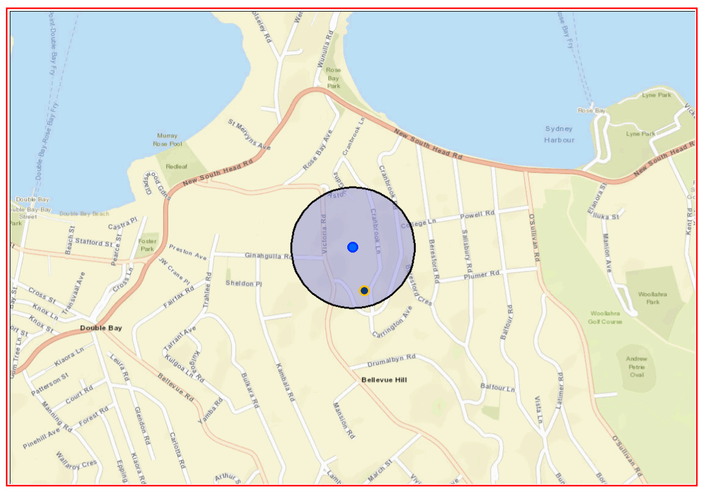
Figure 1. AHIMS search, undertaken by WMC, 28 February 2025.
The site is in an area of Potential Aboriginal Heritage Sensitivity. Therefore, an Aboriginal Heritage Impact Assessment was required as part of the DA to ascertain whether potential Aboriginal cultural heritage will be impacted by the proposal.

An Aboriginal Due Diligence (DD) report was prepared by Urbis in August November 2024. The consultants are known, experienced archaeological consultants. The Due Diligence report was prepared in accordance with the Due Diligence Guidelines, and was undertaken in consultation with the La Perouse LALC who attended the site inspection (1 November 2024).

The site is in an area of Potential Aboriginal Heritage Sensitivity. Therefore, an Aboriginal Heritage Impact Assessment was required as part of the DA to ascertain whether potential Aboriginal cultural heritage will be impacted by the proposal.

At the site inspection, the following observations were made in the AHIA:
A visual inspection of the subject area was undertaken to further investigate the environmental context of the subject area and to determine if any Aboriginal objects were present as surface expressions. The visual inspection of the subject area was undertaken by Aaron Olsen (Urbis Senior Archaeologist), Steven Elle (LPLALC) and Daniel Longbottom (LPLALC). The visual inspection was also attended by Valentina Borfecchia (The Scots College).

The visual inspection was undertaken in overcast conditions and was limited to the area of proposed impacts. Ground Surface Visibility (GSV) was estimated to be 0% across the subject area due to the majority of the subject area being covered by an inground pool, associate plant room, surrounding hardstand and turfed lawn. These observations are consistent with the assessment of that the entire subject area has been impacted by human activities that have changed the surface of the land in ways which remain clear and observable.

No Aboriginal objects were identified during the visual inspection of the subject area.

During the site visit, LPLALC noted that the subject area had been subject to levelling and recommended that harm mitigations measures should include
- provision of an Aboriginal heritage Induction by a representative of LPLALC and
- implementation of unexpected archaeological finds and human remains procedures during the proposed works.

On completion of the AHIA, the report was provided to the LPLALC (6 November 2024) with an opportunity to review and comment. As no response was received, the heritage consultants forwarded the finalised report to Council. Council did respond clearly requesting that the consultant provide evidence from the LALC that the AHIA had been reviewed and that the discussion and recommendations were an accurate representation of the site and inspection. The consultant, from November to February persisted with communications with the LALC requesting a response, to no avail. Over the three months, the LPLALC were contacted on the following dates, with the AHIA attached:
- 6 November 2024
- 14 January 2025
- 28 January 2025

While it is apparent that there has been a genuine attempt by the consultant to consult with the LPLALC with regard to this project, there may be some misunderstanding in the expectation around the level of consultation. In the consultant’s initial work request to the LALC, they had excluded a request to the LALC to include review and comment on reporting after the site inspection. Consultation is expected to be a two-way conversation, and it is Council’s expectation that any means to achieve this is reasonable.

In this instance, the multiple attempted communications with the LALC is considered genuine. The site inspection attended by the LALC, the discussion, observations and recommendations with regards to the work is therefore also considered genuine. and

The LALC provided recommendations verbally onsite. These have been provided for in Conditions of Consent below.

Woollahra LEP 2014

Clause 1.2 Aims of Plan
Subclause 1.2. (2) (f) – to conserve and enhance built and natural environmental heritage

Clause 5.10 Heritage Conservation

The proposal has been considered having regard to the provisions of Clause 5.10 of the Woollahra LEP. The following commentary is provided:

- Clause 5.10(1)(a) and (b): The proposed development conserves the heritage of Woollahra as it would not give rise to unacceptable impact on the heritage significance of the item and its setting, including views to and within the item, and the broader visual catchment.
- Clause 5.10(2) and (3): Consent is required for the proposed works
- Clause 5.10(4): This referral constitutes an assessment under this clause. The effect of the proposal on the heritage significance of the item has been considered and the proposal is found to be acceptable on heritage grounds.
- Clause 5.10(5): A heritage management document was submitted with the development application and was found to be acceptable.
- Clause 5.10(6): A Conservation Management Plan was not required
- Clause 5.10(7) and (8): The site is not identified as an archaeological site or a place of Aboriginal heritage significance. A referral was sent to the La Perouse Local Aboriginal Land Council on 6 November 2024 and no return correspondence was received within 28 days.
- Clause 5.10(9): Demolition of a nominated State heritage item is not proposed.
- Clause 5.10(10): Conservation incentives are not being sought as part of this application.

Woollahra DCP 2015

Part B – General Residential – B1 Residential Precincts
Clause B1.8.2 Desired future character
Objectives O1, O9, O10
- The proposed pool, which will be constructed in a similar position to the existing pool, is considered to have a nil/neutral impact on the desired future character of its immediate setting, and the wider Bellevue Hill North Residential Precinct. While the new pool will result in a small increase in size and therefore a slight amplification of the existing impact, the effect of that impact within its immediate context inside the Scots College context is negligible. It is not an unexpected impact, as the pool will occupy the same space as it has since the 1970s.
- The proposed grandstand will have some impact on the wider setting of the area, particularly as it backs onto the Aston Grove Heritage Conservation Area. The rear of the new grandstand will be visible from the cul-de-sac termination of Aston Gardens. While the impact is new, it is also not unexpected, as there is currently a shade shelter in the location of the proposed grandstand, which is already visible from Aston Gardens. The proposal will result in a large, opaque structure as opposed to the existing high steel paling fence. However, the new structure is in a design and materiality that has a more positive presentation to the Aston Gardens streetscape. The colour scheme and materiality is complimentary, and the bulk of the structure is not such that it obscures or detracts from heritage items within the Scots College, or the significance values of the Aston Gardens HCA. As such, the proposed grandstand building is considered acceptable from a heritage impact perspective.

Figure 2: Proposed development. Expanded pool shown, and proposed grandstand in the rear lefy.

Figure 3: Proposed grandstand.

Figure 4: Existing view of site, from Aston Gardens looking south into the site.

Figure 5: View of site after proposed grandstand development.

Part B – General Residential – B3 General Development Controls
Clause 3.7.4 Ancillary development – swimming pools, tennis, basketball and sports
courts and outbuildings
Objectives (Swimming Pools) O1, O2 (Outbuildings) O1
Controls (Swimming Pools) C2, C3, C5 (Outbuildings) C2
- The proposed swimming pool is considered acceptable with regards to heritage. The proposed excavation will not have any anticipated archaeological impacts, and according to the AHIA and discussions onsite with the LALC, the assessment indicates that the area is considered disturbed and unlikely to contain Aboriginal objects.
- The proposed grandstand, considered an ancillary outbuilding, does not comply with Control C2 and is visible from the Public Domain, specifically from the adjacent Aston Gardens Heritage Conservation Area. However in this instance the minor impact of the Grandstand is considered acceptable on merit. The design and materiality of the Grandstand is considered to have an acceptable impact as it is discreet in its environment which is at the very end of Aston Gardens above some more intrusive garage structures. The materiality of the structure is modern and a more considered and complimentary approach and response to the HCA, than the existing shade structure which presents as temporary and somewhat ad hoc.

Part F2 – Educational Establishments
Clause F2.4 Heritage Conservation
Objectives O1, O2
Controls C1, C2, C4
- The proposed grandstand, considered an ancillary outbuilding, does not comply will be visible from the Public Domain, specifically from the adjacent Aston Gardens Heritage Conservation Area. However in this instance the minor impact of the Grandstand is considered acceptable on merit. The design and materiality of the Grandstand is considered to have an acceptable impact as it is discreet in its environment which is at the very end of Aston Gardens above some more intrusive garage structures. The materiality of the structure is modern and a more considered and complimentary approach and response to the HCA, than the existing shade structure which presents as temporary and somewhat ad hoc (C1, C4).
- The siting of the grandstand will affect views from Aston Gardens HCA into the Scots College, which is a local heritage item. However there are no views from this location to any significant items, and additionally there are no significant, intentional view relationships that form part of the values of Aston Gardens HCA (a collection of interwar RFBs) and The Scots College (a Victorian period education establishment). As such, development in this location is considered to have no impact on the significance of any heritage item involved.

- CONCLUSION

The proposal has been considered having regard to the applicable legislation and policy documents and, on balance, is considered to be acceptable. The proposed pool and grandstand occupy areas where there is already an existing similar use and structure. The impact of the elements to the site constitutes a small amplification of an existing condition, and will have no impact on elements of significance, or on the adjacent heritage conservation area.

- RECOMMENDATION

- No objections are raised to the proposal, subject to the conditions as recommended, as it complies with the relevant statutory and policy documents and would have an acceptable heritage impact.

Consent, subject to conditions below.
- 8B Archaeological Features - Unexpected Findings
- 9B Skeletal Remains
- 10B Aboriginal Objects – Unexpected Findings
- 12B Aboriginal Heritage Due Diligence Responsibilities
- 13B Aboriginal Heritage Induction (LALC Required)

Eleanor Banaag 3 March 2025
Heritage Officer Completion Date

